
Holy Cross College

Semester 1 Examination 2013

Question/Answer Booklet

Year 10 Science
Please place your student identification label in this box
(Extension)

Physics

Student Name
Student’s Teacher

Time allowed for this paper

Reading time before commencing work: 10 minutes
Working time for paper: 110 minutes

Materials required/recommended for this paper

To be provided by the supervisor

This Question/Answer Booklet
Data Sheet

To be provided by the candidate

Standard items: pens, pencils, eraser, correction fluid, ruler, highlighters.
Special items: non-programmable calculators satisfying the conditions set by the School Curriculum and Standards Authority for this course.

Important note to candidates

No other items may be taken into the examination room. It is your responsibility to ensure that you do not have any unauthorised notes or other items of a non-personal nature in the examination room. If you have any unauthorised material with you, hand it to the supervisor before reading any further.
Structure of this paper

Section | Number of questions available | Number of questions to be answered | Suggested working time  (minutes) | Marks available | Percentage of exam
Section One:  Multiple Choice | 50 | 50 | 40 | 50 | 36
Section Two:  Short Answer | 15 | 15 | 60 | 89 | 64
 |  |  |  | 139 | 100

Instructions to candidates

1. The rules for the conduct of examinations at Holy Cross College are detailed in the College
Examination Policy. Sitting this examination implies that you agree to abide by these rules.

2. Write your answers in this Question/Answer Booklet.

3. Working or reasoning should be clearly shown when calculating or estimating answers.

4. You must be careful to confine your responses to the specific questions asked and to follow
any instructions that are specific to a particular question.

5. Spare pages are included at the end of this booklet. They can be used for planning your
responses and/or as additional space if required to continue an answer.

• Planning: If you use the spare pages for planning, indicate this clearly at the top of the
page.
• Continuing an answer: If you need to use the space to continue an answer, indicate in
the original answer space where the answer is continued, i.e. give the page number.
Fill in the number of the question(s) that you are continuing to answer at the top of the
page.

Achievement Standards

The motion of objects can be described and predicted using the laws of physics.
SECTION 1 MULTIPLE CHOICE (50 marks)

Choose the best answer for each question in the Multiple Choice Question booklet.

Mark your selection with a cross.

1 | (a) | (b) | (c) | (d) |  | 31 | (a) | (b) | (c) | (d)
2 | (a) | (b) | (c) | (d) |  | 32 | (a) | (b) | (c) | (d)
3 | (a) | (b) | (c) | (d) |  | 33 | (a) | (b) | (c) | (d)
4 | (a) | (b) | (c) | (d) |  | 34 | (a) | (b) | (c) | (d)
5 | (a) | (b) | (c) | (d) |  | 35 | (a) | (b) | (c) | (d)
6 | (a) | (b) | (c) | (d) |  | 36 | (a) | (b) | (c) | (d)
7 | (a) | (b) | (c) | (d) |  | 37 | (a) | (b) | (c) | (d)
8 | (a) | (b) | (c) | (d) |  | 38 | (a) | (b) | (c) | (d)
9 | (a) | (b) | (c) | (d) |  | 39 | (a) | (b) | (c) | (d)
10 | (a) | (b) | (c) | (d) |  | 40 | (a) | (b) | (c) | (d)
11 | (a) | (b) | (c) | (d) |  | 41 | (a) | (b) | (c) | (d)
12 | (a) | (b) | (c) | (d) |  | 42 | (a) | (b) | (c) | (d)
13 | (a) | (b) | (c) | (d) |  | 43 | (a) | (b) | (c) | (d)
14 | (a) | (b) | (c) | (d) |  | 44 | (a) | (b) | (c) | (d)
15 | (a) | (b) | (c) | (d) |  | 45 | (a) | (b) | (c) | (d)
16 | (a) | (b) | (c) | (d) |  | 46 | (a) | (b) | (c) | (d)
17 | (a) | (b) | (c) | (d) |  | 47 | (a) | (b) | (c) | (d)
18 | (a) | (b) | (c) | (d) |  | 48 | (a) | (b) | (c) | (d)
19 | (a) | (b) | (c) | (d) |  | 49 | (a) | (b) | (c) | (d)
20 | (a) | (b) | (c) | (d) |  | 50 | (a) | (b) | (c) | (d)
21 | (a) | (b) | (c) | (d)
22 | (a) | (b) | (c) | (d)
23 | (a) | (b) | (c) | (d)
24 | (a) | (b) | (c) | (d)
25 | (a) | (b) | (c) | (d)
26 | (a) | (b) | (c) | (d)
27 | (a) | (b) | (c) | (d)
28 | (a) | (b) | (c) | (d)
29 | (a) | (b) | (c) | (d)
30 | (a) | (b) | (c) | (d)

SECTION 2 SHORT ANSWER (87 marks)

Attempt all questions. Write your answers in the spaces provided.

1. Convert the following to standard units (kilograms, metres, seconds), using scientific
notation where possible.

(a) 36.3 ms (b) 2.45 days

(c) 2.15 x 10³ km (d) 27.5 cm²

(4 marks)

2. Perform the following calculations, giving your answers to the correct number of significant
figures.

(a) 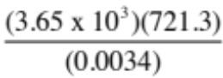

(2 marks)

(b) 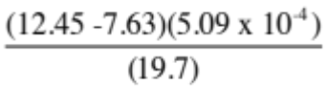

(2 marks)

3. (a) John and Paul are pulling on a 42.0 kg box with forces of 70.0 N south and 45.0 N east.
Draw a vector diagram for this situation and calculate the resultant force.

(4 marks)
(b) What would be the acceleration of the box?

(3 marks)

4. A plane flies due north at 7.50 x 10² kmh⁻¹ for 1.50 hrs and then due west at 6.00 x 10² kmh⁻¹
for 2.00 hrs. Calculate:

(a) the distance covered.

(3 marks)

(b) the plane's average speed.

(2 marks)

(c) the plane's average velocity.

(5 marks)

5. Some students investigated the movement of a dynamics trolley across a bench using a ticker
timer to record the motion. The timer puts 50 dots per second (1 dot-spacing = 0.02 sec) onto
the tape, and the tape is shown below.

. . . . . . . . . . . .

Analyse the tape to determine the acceleration of the trolley. Show all of your working
below.

(4 marks)
6. A dragster at Kwinana Motorplex covers the 4.00 x 10² m track from a stationary start in
4.95 s. The acceleration can be assumed to be uniform for the entire motion.

(a) Calculate the acceleration experienced by the driver.

(3 marks)

(b) What is the velocity of the dragster as it crosses the finish line at 4.00 x 10² m?

(3 marks)
7. The graph below shows the motion of a bicycle over a 20.0 s period.
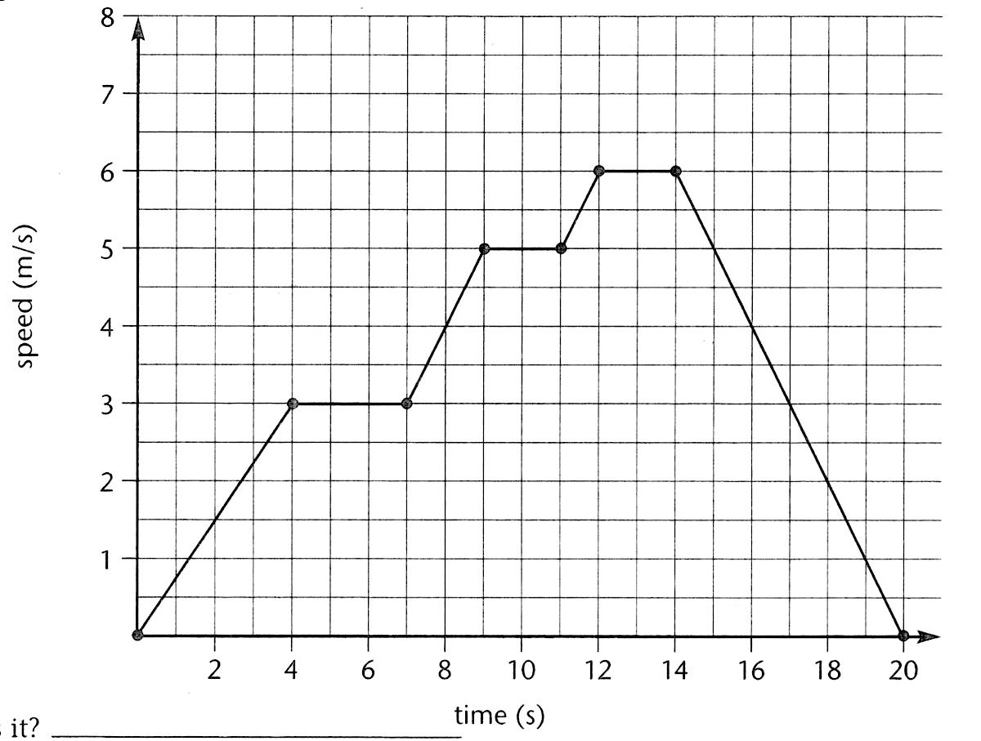

(a) During which time intervals was the bicycle travelling at a constant velocity?

(2 marks)

(b) Calculate the deceleration of the bike as it came to a stop.

(3 marks)

(c) From the graph, determine the displacement of the bike over the first 11.0 s of
movement.

(4 marks)
8. A Year 10 student threw an orange up to another student on the first floor
4.80 m
balcony outside the Year 11 rooms. It is caught 4.80 m above its release
point, having been thrown upwards at 11.5 ms⁻¹. The student caught the
orange as it was falling downwards, having reached its highest point.

(a) What is the maximum height reached by the orange above the point
of its release?

(3 marks)

(b) What is the velocity of the orange when it is caught?

(3 marks)

(c) How long is the orange in flight?

(3 marks)
9. Vincent dropped a stone down a well and saw it hit the bottom 3.5 s later. How deep is the
well?

(3 marks)

10. Sean is driving his car along Roe Highway at 90.0 kmh⁻¹ when he steps on the brake pedal of
his car for 2.5 s. This applies a retarding force of 2.10 x 10³ N to slow his 1.35 x 10³ kg car,
which is travelling in an easterly direction. Calculate his car's final velocity.

(4 marks)

11. Max has a mass of 57 kg on Earth. He is lucky enough to be selected for a junior astronaut
programme and journeys to the International Space Station (ISS) for a 3-month stay.

(a) Calculate Max's weight on Earth.

(3 marks)

(b) Max "floats” in space within the ISS. Is he weightless? Explain your answer.

(2 marks)

(c) Is Max ever weightless in space? Explain your answer.

(2 marks)

12. A 60.0 kg skateboard rider moving at 1.00 ms⁻¹ drops into a 'half-pipe" that is 4.00 m deep.

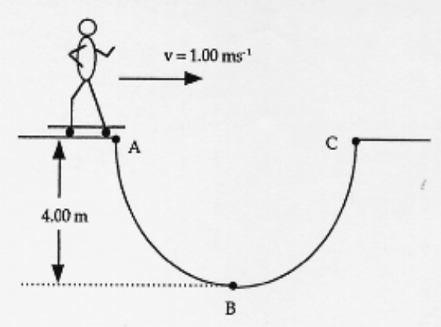

(a) Calculate the total energy of the rider at point A.

(4 marks)
(b) How fast would the person be moving at point B?

(3 marks)

13. The Bugatti Veyron is the fastest production car in the world (as at 2013). It has a mass of
1.88 x 10³ kg and set the record at 431 kmh⁻¹. In order to stop, it has ceramic brakes that can
stop it from 100 kmh⁻¹ to a stop in just 31.4 m.

How much work do the brakes do in stopping the car during a braking test?

(4 marks)
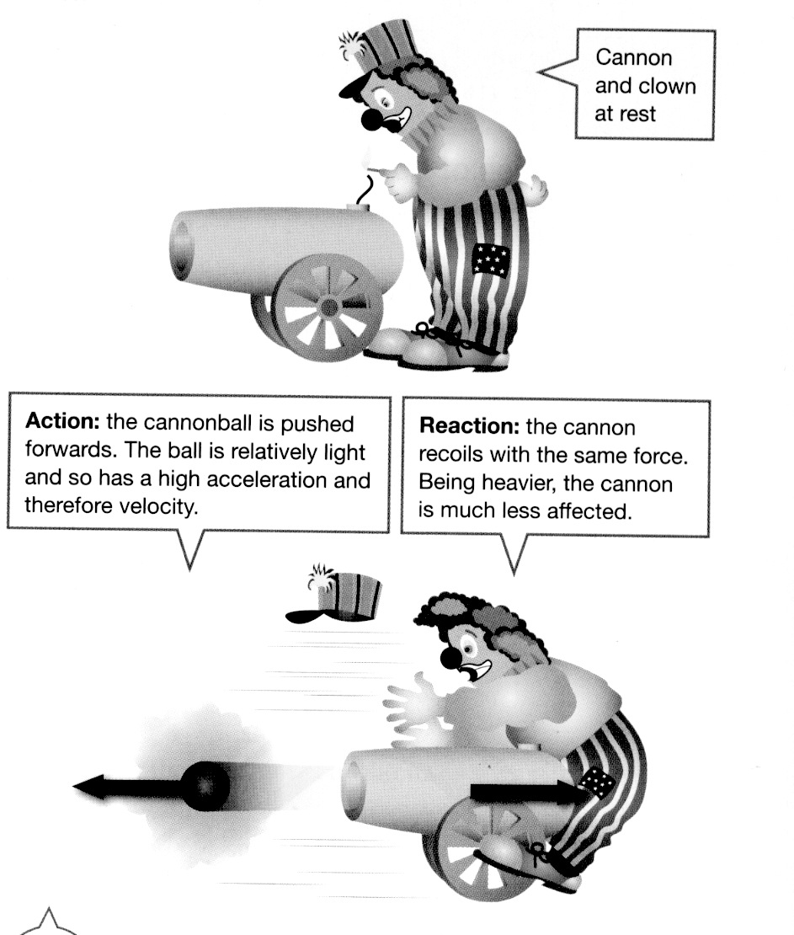

14. Look at the diagram showing a clown and a cannon at
a circus. Analyse it and explain why the cannon hits
the clown, using Newton's Laws in your explanation.

(2 marks)
15. A group of students investigated the acceleration of a marble down a grooved aluminium
track that was elevated as shown below.

The marble was released from rest at various distances from the bottom of the track and the
time taken to reach the bottom was recorded as shown below.

The relationship being investigated was s = ut + ¹/₂ at².

Jessica and John decided that, given that the marble was initially at rest, the equation reduces
to s = ¹/₂ at². They discussed how to generate a straight line graph and decided to square the
t values. The gradient of the line of best fit would equal ¹/₂ a.

s (m) | 0.20 | 0.40 | 0.60 | 0.80 | 1.00 | 1.20 | 1.40
t (s) | 0.56 | 0.82 | 0.99 | 1.12 | 1.29 | 1.41 | 1.49

(a) Use the third row of the table to record the data manipulation done by Jessica and John
in order to generate a straight-line graph.
(2 marks)

(b) Graph the data on the grid on the next page. Draw in a line of best fit.
(4 marks)

(c) Use the gradient of the line of best fit to determine the acceleration of the marble down
the track.

(3 marks)

END OF EXAMINATION

THIS PAGE HAS BEEN DELIBERATELY LEFT BLANK.
THIS PAGE HAS BEEN DELIBERATELY LEFT BLANK.
THIS PAGE HAS BEEN DELIBERATELY LEFT BLANK.

